**DAILY ONLINE ACTIVITIES SUMMARY**

|  |  |  |  |  |  |  |  |  |
| --- | --- | --- | --- | --- | --- | --- | --- | --- |
| **Date:** | **29/05/2020** | | | | | **Name:** | **Pragathi h d** | |
| **Sem & Sec** | **8 sem B sec** | | | | | **USN:** | **4AL16CS066** | |
| **Online Test Summary** | | | | | | | | |
| **Subject** | | **BDA** | | | | | | |
| **Max. Marks** | | **30** | | **Score** | | | **21** | |
| **Certification Course Summary** | | | | | | | | |
| **Course** | **Introduction to ethical hacking** | | | | | | | |
| **Certificate Provider** | | | **Great Learning** | | **Duration** | | | **6.00hrs** |
| **Coding Challenges** | | | | | | | | |
| Problem Statement: 29 may Hamiltonian and Lagrangian | | | | | | | | |
| **Status: Solved** | | | | | | | | |
| **Uploaded the report in Github** | | | | | **Uploaded** | | | |
| **If yes Repository name** | | | | | **Pragathijain** | | | |
| **Uploaded the report in slack** | | | | | **yes** | | | |

Online Test Details: (Attach the snapshot and briefly write the report for the same)

Certification Course Details: (Attach the snapshot and briefly write the report for the same)

Coding Challenges Details: (Attach the snapshot and briefly write the report for the same)

Online coding challenge

|  |
| --- |
| n=int(input()) |
|  | l = list(map(int,input().split()))[::-1] |
|  | pq = [] |
|  | pq.append(l[0]) |
|  | m = l[0] |
|  | for i in range(1,n): |
|  | if l[i]>=m: |
|  | pq.append(l[i]) |
|  | m=l[i] |
|  | print(*pq[::-1]) |
|  |  |
|  |  |
|  |  |
|  |  |
|  | #input: |
|  | #6 |
|  | #16 17 4 3 5 2 |
|  |  |
|  | #output: |
|  | #17 5 2 |

Certification course details

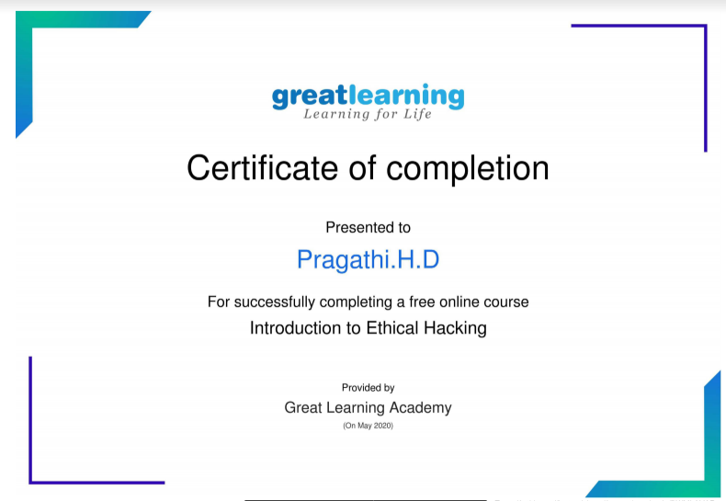

Online test

